Mediatized Discourses on Europeanization in Hungary*
György Lengyel - Gabriella Ilonszki – Borbála Göncz – Lilla Tóth – Attila Melegh

1. Introduction

This research investigated how European integration and Europeanisation were represented and constructed by the Hungarian elites and the media, and how these appeared in the Hungarian public opinion. In the triangle of elite, media, and public opinion we aimed to identify the basic features of relevant discourses, the prime movers and the patterns of public perception.

In political respects Hungary has gone through democratic subversion since 2010 under Fidesz government and the uninterrupted prime ministerial leadership of V. Orbán (Kelemen 2020; Ágh 2016; Bogaards 2018). Initially the EU followed democratic subversion passively. By 2022 the diverging interests between the EU and the Hungarian government became manifest via infringement actions with reference to the Rule of Law Conditionality Regulation. The transformation of the political and economic circumstances after 2010 has led to a significant change in the way politicians speak publicly about the EU (Berend 2021). Previously predominant technocratic and pro-European discourses have been replaced by symbolic messages about national sovereignty (Fabbrini-Zgaga 2024; Verzichelli 2020), in which the EU has been presented in a negative role, often as a threat. Discourses about the EU rarely reflected the fact that Hungary was part of the EU, and the EU was generally seen as an external actor.

The overall media situation (Hallin & Mancini 2004; Urbán et al. 2017; Dobek-Ostrowska 2015, 2019; Bátorfy 2019; Dragomir 2019; Martin 2019) has had a major impact on the development of the discourse. With the authoritarian turn, the Hungarian media system features high polarisation, signs of capture by the government, and low public trust. The media conditions follow similar polarisation that we can observe in the realm of politics: pro-government media supported by huge public resources dominates while independent, market-based media outlets struggle to survive (Éltető & Martin 2024; Hann et al. 2023; Urbán 2024; Bajomi-Lázár & Horváth 2023).

Democratic subversion has gone in parallel with elite transformation (Lengyel & Ilonszki 2016; Ilonszki & Lengyel 2024). The takeover of the Orbán government in 2010 was not a mere government change, which would normally bring about changes in elite positions, but also a break with the elite consensus on the liberal-democratic foundations of the system, and a thorough transformation of the political, economic, and media elites, leading to sweeping systemic consequences.

In the research process we have conducted content and discourse analyses of the influential media outlets followed by interviews with the political and media elites to identify the main Europeanisation discourses and their components. We will discuss how different discursive blocks have emerged and how polarisation has strengthened. Building on the previous phases, with a public opinion survey we have explored public views on the EU and Europeanisation. We will highlight how public views on European integration are influenced by pragmatic and identity-based symbolic aspects, as well as by the public’s perception of the role of elite and media in the country’s Europeanisation.

2. EU media discourses and their ramifications

The aim of this part of the project was to identify and analyse media discourses on the EU between July 2021 and March 2022. During this period, the political landscape was extremely turbulent: the run-up to the upcoming parliamentary elections intensified government propaganda on the EU, and opposition parties built up a pro-active collaborative strategy to counter the populist and EU-sceptic stance of the dominant pro-government media. The elections in April 2022 brought about the success of the Orbán government again. Russia’s aggression against Ukraine had a role in Fidesz victory and influenced the EU-related discourse as well: the EU ever since appears as a scapegoat for “mishandling” the war, which is presented as a point of reference to explain measures such as governing by decrees or economic underperformance.

At this stage of the research, we selected eight widely known Hungarian media sources (CORPUS8) including public and private, online and print, pro-government and pro-opposition media. We monitored the evening news programmes of two television stations, one public and one private (M1 and RTL), and the online and print versions of two daily newspapers, the pro-government Magyar Nemzet (MN) and the government-critical Népszava (NSZ). In addition, two popular online publications (HVG and ORIGO) were also included, the first from a government-critical and the second from a pro-government side. Finally, we added HÍR TV and ATV, where political debates were frequent. The former is pro-government, the latter used to represent liberal-critical positions, although recently this characterisation was questioned due to the change of ownership and tone.

In the selected media, we collected items containing the following keywords related to the EU: European Union, EU, Brussels, European Parliament, European Commission, and European Council. About two thirds of the corpus (articles, news, transcripts of conversations) appeared in pro-government media, one third in government-critical or neutral media. Then, based on the preliminary research and test coding, we processed further selection within the corpus, using additional keywords per macro topics that had attracted public interest during the period under study. Macro topics allow for the analysis of the relationship between text and social context and can thus be used to explore discourse characteristics (Wodak 2020). European identity and the future of Europe, migration, pandemics, disinformation, war, and sexual minorities were the macro topics analysed in the subsamples of the EU-related corpus.

It is a common feature of the analysed media that incumbent politicians are vastly overrepresented among the speakers. This connects to - and partially explains - some features such as the dominance of overarching and symbolic themes in discourses. Politicians tend to displace experts and journalists not only in the news, but also in articles and opinion-forming reviews. A handful of government politicians channel the communication themes to the media. International speakers are less frequently speaking, and they are better visible in the opposition media outlets. Figure 1 shows patterns of EU perceptions in the two major dailies.

Figure 1. Perception of the EU in two dailies: the pro-government Magyar Nemzet (MN) and the government-critical Népszava (NSZ) (%)

Sample: first three weeks of July and November 2021

The first lesson of the content analysis is that the vast majority of the corpus contained neutral factual information without evaluative elements. But - and this is the second and more important lesson - in those articles where the EU was the dominant topic, we could observe a significant divergence in the tone of the pro-government and government-critical media. The pro-government MN broadcast a predominantly negative view of the EU, while the assessment of the government-critical NSZ was more neutral and balanced. The share of positive EU assessments in both media sources was around 8%. The government-critical media is critical of the EU when it feels the need to be and is not characterised by a one-sided tone of praise. It uses the tools of argument and counterargument more often, and in some cases shows the characteristics of internal pluralism. The difference between the two types of media is that while the pro-government media is critical of the EU but not of the government, the government-critical one is occasionally critical of the EU as well. In the former, articles critical of the EU are predominant, in the latter, articles with a positive and negative tone are roughly balanced, but neutral and balanced items dominate.

From the perspective of discourse analysis two major blocks emerged: the views of sovereigntism and integrationism. The sovereigntist block’s discourses characterise the dominant pro-government media’s view of the EU. The pragmatic and identity factors are inherently intertwined in all relevant discourses, since sovereignty is the main interpretative framework, and pragmatic aspects are dominated by identity-based lines (Wodak 2020). According to this view, the Hungarian government is only trying to protect the 'tradition' and 'normality' that Hungarian citizens and European people across the EU want and demand.

The sovereigntist position is best expressed in positive terms by the phrases that “Hungary is the defender of traditional European values” and "a strong Europe must be built on strong nations". In a negative sense, however, the emerging sovereigntist stance is pervaded by nativism and an "Us versus Them" interpretation of Hungary-EU relations, where "Them" is frequently identified with the West itself. The 'West' is often described as decayed, abnormal, sick, and consequently only the Central European region can defend the European tradition. The pro-government media, when using this discourse, constantly reconstructs the message that the united opposition wants to sell the country to the "West" and gives up all traditional, Christian, Hungarian values. The mobilising ideology of the ruling elite, based on an image of the enemy, enforces polarisation in domestic politics. Figure 2 shows the most prominent sovereigntist and integrationist discourses on the EU by their appearance in the headlines.

Figure 2. EU-related Hungarian sovereigntist and integrationist media discourses

Sample: EU-related material of CORPUS8 between July 2021 and March 2022.
Legend: S – sovereigntist; I - integrationist

The other discursive block also includes several discourses, represented mainly by the pro-integration category, which recognises the necessity of further integration. This includes those who ascribe moral or symbolic value to the EU and report a European identity as well as those who recognise the pragmatic benefits of a liberal and managed central administration based on appropriate regulatory and redistributive powers. The East/West discourses are based on the dominance of the West, which is to be rejected or accepted as a model for Hungarian future developments.

Integrationism is organised as a counter-discourse to sovereigntism in the media in two ways. Directly, - and more frequently - when it seeks to refute or challenge a sovereigntist claim. Indirectly, as in Figure 2, when it brings forward the EU's role in protecting democracy, and issues that criticise the government, such as the discourses of corruption, or disinformation.

In this way, there is a dominant nationalist block which claims that Hungary and Hungarians are European already but are treated as second class by mainstream Western European discourses which came into being as early as in the late 1990s (Melegh 2006). There is an additional one, which would like to counterbalance “Eastern” nationalism, via civilizational upgrading, which also came into being in the 1990s already. The nationalist views among others rely on reactivated topics of Hungarians’ Eastern origin as voiced between the two World Wars (i.e. Turanism). The reactivation (Foucault 1991) of the historical memory of the Hungarians’ claimed Turkic origins is part of the arsenal of identity politics, in the spirit of opening to the East. It is left unclear how this is compatible with the discourse of Hungary as the bastion of Christianity.

The sovereigntist and integrationist blocks are linked with a West-East hierarchical image, but with different interpretations. In most sovereigntist discourses, the West is a source of threat, while in the integrationist discursive block it is a guarantee of freedom and prosperity. Another type of connection/link is that the dominant discourses of some macro-topics appear as sub-discourses of others as well.

When an immanent critique of the EU does emerge among integrationist views, it tends to be of a pragmatic nature, targeting, among other things, negative side effects, information vacuums and bureaucratic slowness. In this framework, integration is a concept with multiple meanings, and the strengthening of federal institutions is one possible interpretation along with others, such as infrastructure development and enlargement.

The contrast between the two discursive blocks on the EU is rooted in the highly polarised nature of politics and the polarised media, which all increase the sense of insecurity and distrust (Melegh 2023). There is a parallelism between politics and the media, i.e. both politics and the media are asymmetrically polarised, with the predominant influence of the governing elite. As mentioned above, the reason for parallelism between politics and media is a media capture carried out by the governing elite (Éltető & Martin 2024; Dragomir 2019). While polarisation is an increasingly common feature of European politics today (Beaudonnet & Gomez 2024, Bettarelli et al 2023, McCoy & Sommer 2019, Guriev & Treisman 2020), this asymmetric polarisation further explains the characteristics of the discursive blocks, both in terms of influence and orientation towards the EU. Table 1 provides a summary of discourses concerning EU-related macro topics.

Table 1. Sovereigntist and integrationist discourses according to macro topics

Sovereigntism | Integrationism | Macro topic
Hungary is the saviour of traditional European values of Christianity and family;  Don’t let Brussels dictate us;  Today Europeans have no right to their country… their family, their God;  We are the only Eastern people left in Europe | The EU is a guardian of democracy and rule of law;  The EU protects human rights and minorities;  European and national identities are compatible;  Hungary belongs to the West | National and European identity
A strong EU must be built on strong nations;  The EU is creaky, Hungary has a clear and consistent vision;  The EU builds an empire and applies double standards | The EU should be empowered;  The EU should become an effective regulator of nationalist extremism and norm breaching | Future of Europe
Migration is the plan of George Soros and the EU;  Migration is a security issue | The EU manages a humanitarian solution to the refugee crisis;  The EU represents the “normal” management of migration and the related fundamental values | Migration and the EU
Hungary performs better than the chaotic EU in tackling the epidemic;  Russia and China perform better;  The EU is selfish, it exploits the crisis to advance its own interest | Hungary underperforms in healthcare and economic competition;  Eastern procurement of vaccines and ventilators by the government is a hotbed of corruption;  Because of grand corruption of government clients, there is no money for healthcare and education | Pandemic and the EU
Discourse about disinformation helps the expansion of EU-bureaucracy | The Hungarian public media use Russian propaganda as a source | Disinformation and the EU
Hybrid warfare is between the normal people and the liberal lobby;  hybrid war is fuelled by the EU | The migrant crisis on the Polish-Belarus border is part of Russia’s hybrid war against the EU | Hybrid war and the EU
EU sanctions ruin us;  The left and EU would take the country to war, Fidesz guarantees peace;  We will not let us pay the price of the war;  EU sanctions endanger energy safety | The lies of Fidesz ruin us;  Hungary is part of the West and needs to be loyal to its allies, not to Russia;  The Hungarian government plays a dangerous game when it simultaneously seeks the favour of Russia, China, Trump and the European far-right;  EU sanctions are justified, but they can also punish those who should be supported | War, security, geopolitics, EU
LGBTQ and gender propaganda infiltrate kindergartens;  The EU wants to take away the parents’ rights, and the Hungarian government only protects families;  LGBTQ propaganda harms the mental health and sexuality of children | Family is family;  The government deliberately confuses homosexuality with paedophilia | LGBTQ propaganda and the EU

We could identify a number of eponyms such as Soros or Brussels, which were born in sovereigntist discourses and then spilled over into the public discourse through media advertisements and giant posters. Discursive elements are often repetitive, key messages of one macro-topic appear in other macro-topics as well. The praise of Hungarian performance in sovereigntist discourses reappears in the topics of pandemics, migration, and the future of Europe. By contrast, in the integrationist argument these are denied, the EU’s civilizational impact is emphasized in a variety of contexts.

Pragmatic discourse is subordinated to identity issues in the government media, and it is weak even in the neutral and government-critical media as these media outlets often reflect and respond to the dominant government discourse. This appears to be a discursive trap in the given context, as it places the narrative in an ideological field and thus overrides the possibility of confronting everyday experience.

It happens - particularly regarding the themes of migration and Russia’s war against Ukraine - that there is silence about crucial facts and interpretations. This “empty space” is filled with “commentary” on the EU as intended by the communicator. The EU is instrumentalised: its claimed negative role in these events serves as a disguise to reject reality. Some narratives – which often connect to fundamental values, like humanitarian aspects of migration - disappear from the discourse and are superseded by fake news. In such cases, the rhetorical device of "whataboutism" is often used: instead of uncomfortable facts, an alternative topic is raised that may embarrass the other party.

Our research shed light on the versions of silence (Melegh 2023; Hameleers et al. 2023). Certain types of refugees, uncomfortable facts and comparative data, names of political opponents, and initially even the naming of the war could all sink into silence. At the other pole of silence, we find the example of the Hungarian exit from the EU, which was not in the sayable range in the pro-government media, despite the EU-critical tone. All of these relate to democratic subversion supported by the asymmetric polarisation of the media in which the government-critical press cannot reach a significant part of the public.

3. Elite Discourses: Q sorts and their underlying assumptions

Sixty members of the Hungarian political and media elite were interviewed between November 2022 and March 2023. The sample of elite interviews reflects the two-thirds to one-third government-opposition split identified in the previous phase of the research. The sample of political elites was drawn from Hungarian Members of Parliament, Hungarian Members of the European Parliament and senior officials. The media elite included the editors-in-chief and senior journalists of print and online newspapers, television and radio stations, as well as board members representing the owners. We applied the snowball approach to reach respondents and ensured confidentiality throughout the process using code numbers for the interviewers and respondents alike. The 60-member sample consisted of 49 men and 11 women, half of the sample was over 50 years old, 29 belonged to the political elite and 31 to the media elite. The former group consisted of 17 MPs and MEPs and 12 civil servants while the latter included 24 editors and journalists, in addition to 7 media owners. In terms of political self-classification, cc. 60% claimed to belong to the right, roughly a quarter to the left and the rest to the centre with a score of 4 on a 7-point scale.

The Q-analysis of the elite interviews identified four main factors: the integrationist, sovereigntist, multi-speed and Huxit stances. We could rightly assume that the factor structure accurately describes the views of Hungarian political and media elites on European integration as the statements were imported from media discourses where elite opinions dominated, moreover respondents commented on their choices and in most cases approved that the presented statements were relevant. Their arguments convincingly supported and refined the factor ranking decisions.

Figure 3 introduces the pattern of the integrationist factor. This factor represents those who share pro-integration views in terms of promoting further ties and strengthening institutions within the EU. In addition to economic benefits, many highlight the freedom to travel:

We receive 4% of Hungary's GDP from the European Union, without EU support, there would be a very serious recession in Hungary, which is also to be expected if we could not agree very quickly on the original funds, and then we do not discuss the next seven-year cycle about the funds. So, we are absolutely a net beneficiary of the European Union financially. This is one, the financial side, and the social side is mobility. The fact that anyone can go to the West to learn, to live. The boundaries have become more or less formal. … So, the world opened up (member of the political elite, opposition).

Critics of the government point to the constraints the EU places on political autocratisation:
If there was no EU [here], it would be a hybrid democracy of the 1930s and a mixture of the
Putin era (member of the government-critical media elite).

The pro-integrationist position includes federalism, as well as the support of EU enlargement, pragmatic considerations related to the EU’s role in reinforcing the country’s democracy and security, and the strengthening of cultural ties among European countries. Some representatives of this view attach outstanding historical importance to European integration:
[That] the integration of the EU should be continued... I put it here among the strongest yes-
s, because I think that European integration was one of the greatest achievements of the 20th
century (member of the government-critical media elite).

Figure 3. Characteristic features of the integrationist factor within the elite
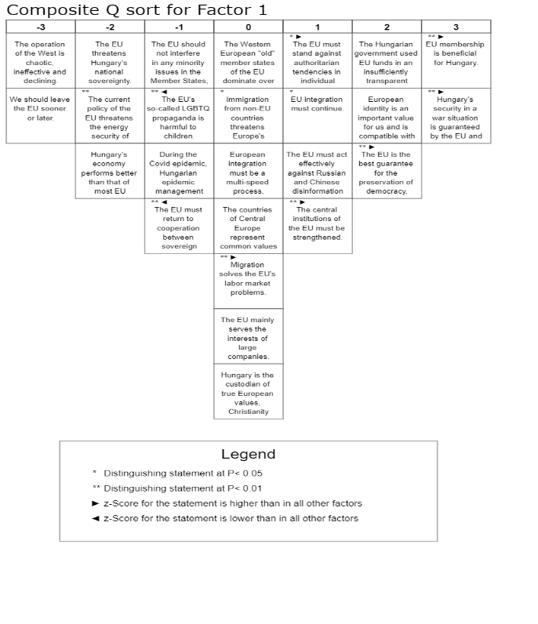

The second strongest factor supports the reinforcement of sovereignty. Its pattern is introduced in Figure 4. The statements comprising this factor emphasise that the EU’s institutional developments and symbolic gestures point toward the wrong direction:

This is a debate between two concepts, the Europe of nations and a federal Europe, and I firmly believe that, as the founders of the European Union and Coal and Steel Community and the founders of the European Community, in the 1950s, Christian-democratic politicians thought that the right line was the Europe of nations and nation-states, and this federal Europe, this is a non-existent fiction, and nothing good will come of it (member of the political elite, government).

They claim that the EU’s sanctions pose a concrete threat to Hungary’s energy security:

The current EU policy is endangering the energy security of Hungarian households, as is clear from the way prices are rising, and we are lucky to have a much better petrol price, at least temporarily. So, it was shocking to see in the last few months that in Germany, for example, on Sunday, there is no traffic on Sunday. It got very little publicity, but it was a state organisation, so it was not voluntary. Or in France, for example, when we went to Strasbourg, how shocking it was queues at the petrol stations. That was not the plan here. It can be clearly compared what the difference is (member of the political elite, government).

According to sovereigntists, the government’s corruption-free record with EU funds is unquestionable and its defence against EU interference is justified:

I don't think the EU uses its existing power well in economic matters, and it does use it terribly in political matters (member of the political elite, government).

On the part of the European institutions, the two very common accusations are the rule of law accusations in general, and especially the use of European Union funds... not so much its transparency, because I think its transparency is clear, as the Hungarian laws, such as the Public Procurement Act, is one of the strictest... in the entire European Union. So, no one can say that resources are used in a non-transparent manner. … the EU institutional system launches political attacks against Hungary (member of the political elite, government).

They believe the EU’s central authorities are unfair and apply double standards to stifle dissent. They deny that migration could have a positive impact on the labour market or that the EU should act against Russian and Chinese disinformation in member states. The sovereigntist view is largely based on domestic electoral considerations and defends the government’s political position. Somewhat in contrast however, the sovereigntist view includes that the EU and NATO guarantee national security:
For Hungary, EU membership is beneficial, and being a small, weak country, its security
can only and exclusively be guaranteed by its Western allies, so this is out of the question
(member of the political elite, government).

According to the sovereigntist perspective, European and national identities are compatible. This explains – just like in case of the elite members who share the integrationist and multi-speed outlook – why the sovereigntist elite members are also against leaving the EU.

These internal contradictions verify that the discourse of endangered sovereignty serves tactical performative purposes, and that European integration is instrumentalised among the incumbent elite. It signals the opposition to 'Brussels', designates the enemy for mobilised followers while accepting the EU’s framework and values. We will see below that the message is not always interpreted in this way among followers though, as its internal distinctions and nuances may well be misunderstood or overlooked.

Figure 4. Characteristic features of the sovereigntist factor within the elite

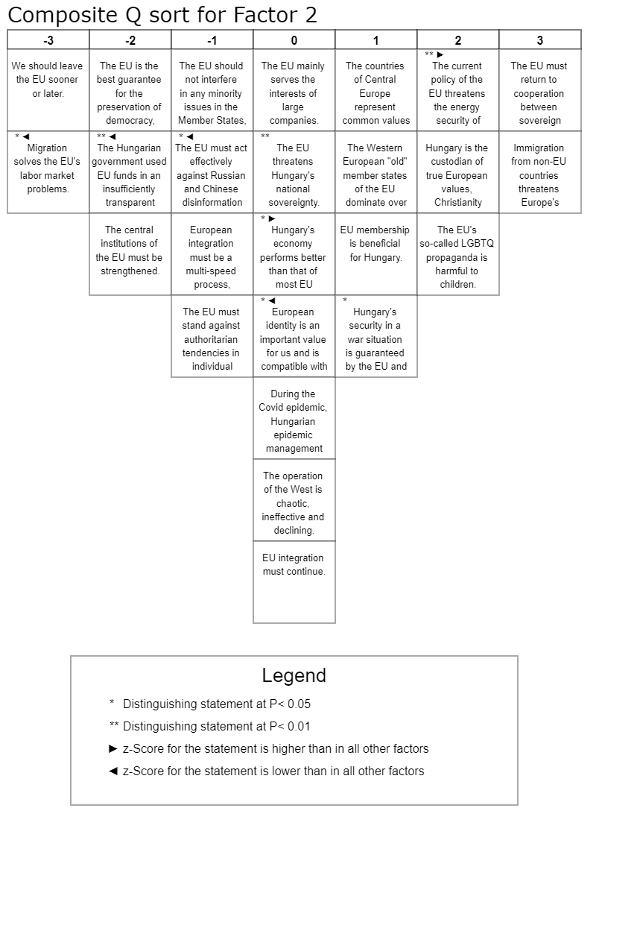
In addition to the two main factors – integrationist and sovereigntist – we find two marginal factors: the multi-speed EU and the Huxit alternatives. The first suggests that each member state should proceed with integration according to its own readiness and will. According to the second, Hungary, like the UK, will have to leave the EU sooner or later. Figure 5 and Figure 6 below present the components of these two factors subsequently.

At this stage, we should also note that factor types tend to connect to particular modes of discourse. We have identified a normative and a contemplative discourse mode. In the normative discourse, the claims and demands are clearly formulated, the modals of “should” and “must” or “must not” are frequently applied, and the interviewee’s personal, often emotionally charged opinion is expressed. In the contemplative discourse, the topic is described as an object of analysis, where pros and cons are often weighed. The interviewee may form an opinion, or the personal opinion may remain hidden. These are not necessarily differences between politicians and journalists, but differences between attitudes that connect to discourse patterns. Multi-speed EU and Huxit discourses appear more often in the contemplative-analytical discourse mode.

Figure 5. Characteristic features of the multi-speed factor within the elite

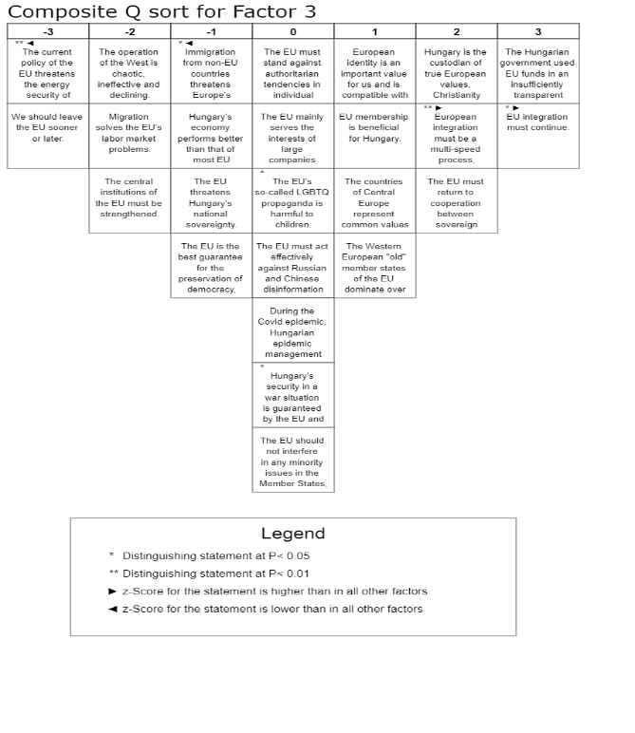
Although the multi-speed approach is compatible with both the sovereigntist and the integrationist viewpoints, it departs from them in important details. It particularly differs from the support of sovereignty, as it makes the tighter integration goal explicit:

Now there is a very, very big difference between paying in euros three years from now or never paying in euros. And that this is an existing goal that we want to achieve, we are working on it, we just don't know yet. The first one is obviously an understandable, multi-speed process, there are more speeds because there is a constraint, but they will grind together somehow. The other one says that it's good that way, that it's here there it is. I think it's really not good (member of the pro-government media elite).

The multi-speed discourse is based on the principle, expressed among others by President Macron, that each country should move forward with integration according to its own readiness and will. As a member of the pro-government media elite argued, it is "because the preparedness, attitude, history and past of the member states are very different". In the Hungarian elite context this discourse claims that the government is not using EU funds in a transparent way. Furthermore, it denies that the Hungarian economy is performing above the EU average or that the West is chaotic and declining, themes that characterise the sovereigntist factor. It is categorically opposed to the idea of Huxit, or that the EU threatens Hungarian sovereignty and the energy security of Hungarian households. It positively assesses the benefits of the EU on a pragmatic basis and recognises European identity, while claiming that Hungary is the embodiment of true European values, the defender of Christianity and family values.

The claim of the fourth factor (Figure 6) that we call the Huxit factor is that Hungary must eventually leave the EU. This view is held by a small proportion of respondents belonging to the far-right opposition. They see the EU as the embodiment of negative trends and as a threat to Hungary’s independence and energy security.

Figure 6. Characteristic features of the Huxit factor within the elite

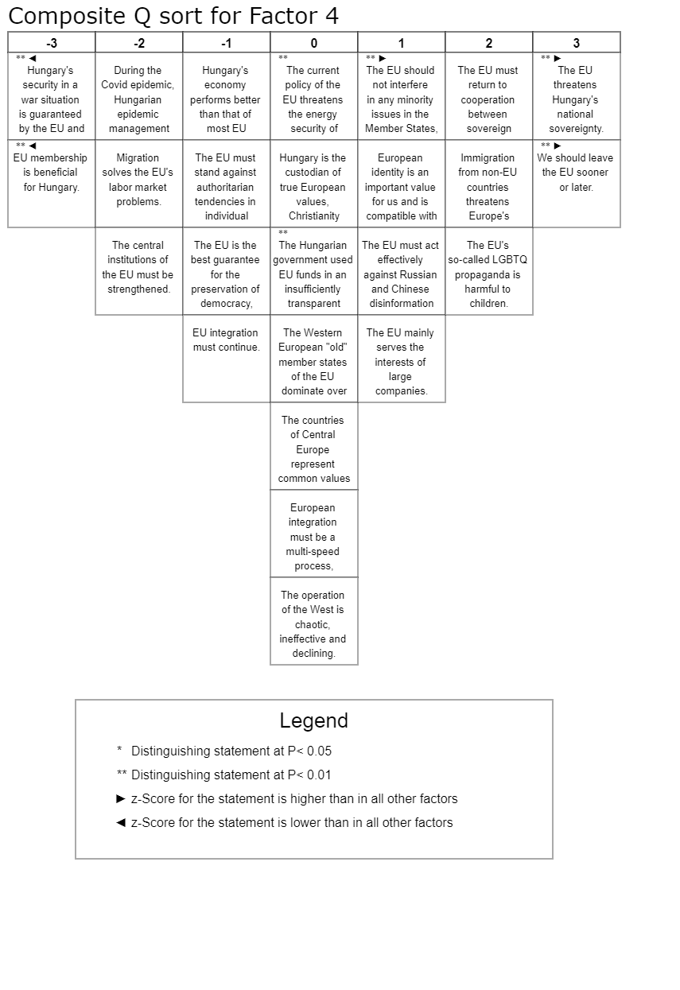

They deny that EU membership is beneficial for Hungary:

They are colonizing us, I think, especially Germany… they take more money out of the country than comes here as EU support… even the policy of Fidesz, which is very critical of the EU, accuses Brussels of bureaucratization, places all responsibility on Brussels, and makes Brussels the scapegoat, ultimately says that it is much better within the Union and there is a completely excluded, absurd idea that the Union should be left. However, the example of Great Britain also shows that there is life outside the EU. Even after the Union, I think you should mostly prepare for that (member of the political elite, far-right opposition).

The Huxit factor argues that the EU should not interfere in minority issues within member states. This factor is close to the sovereigntist positions, especially on questions of migration and gender, but represents a more radical version. At the same time, it also incorporates views that are critical of the government, and in particular, that the government does not manage EU funds in a transparent way.

The Q-analysis on the views of political and media elites confirmed and nuanced the picture obtained from the media analysis. Here again, integrationism and sovereigntism proved to be the two dominant discourses; nevertheless, two marginal factors also appeared: multi-speed Europe and Huxit. The media, as we have seen, were dominated by the sovereigntist approach. This was in parallel with the views of the incumbent political elite. In contrast, most opposition politicians as well as government-critical and neutral media elites held integrationist views. A minority supported the multi-speed Europe alternative, and a marginal far-right party took the Huxit position within the elite. With this it was also confirmed that the vast majority of the Hungarian political and media elites remained committed to the EU during the period of analysis, despite their alternative visions of desirable EU developments.

- Survey results, public views about the EU, the elite and the media

The aim of the nationally representative survey of 1,021 respondents was to analyse opinions of the Hungarian adult population about European integration, and the role of elites and media in this process. Given the increasing political polarisation and the dominance of pro-government media propaganda highly critical of the EU in the observation period, first we wanted to reveal the interest of the public and the reflection of public interest regarding EU-related matters. How and on what grounds do they reflect on the discourse patterns of the elite and the media?

The survey found that just over half (56%) of the population have a low level of interest in politics, while 44% say they sometimes or often discuss political issues. At the extremes: around 12% of the population say they never talk to their friends about politics, while one in nine do so often. Gender is not related to cognitive mobilization as opposed to age: the majority of young people claim that they do not or rarely participate in political debates, compared to the 45-64 age group, which is the most interested one. The political interest of the retired age group is around the national average. In addition to age, occupation has a significant impact on political interest. Typically, managers and professionals show well above average political interest levels, while unskilled workers and those in clerical or service jobs show significantly below average political interest levels.

In terms of political affiliation, about 30% of the population identify themselves as left-wing, 44% as right-wing and about a quarter as somewhere in between. Political interest is significantly higher on the left and is average on the right. The vast majority of those in the middle never discuss political issues with people they know.

A relative majority of the public clearly notes both elite and media disunity in relation to EU affairs. Half of the public believe that the elite is not united, and only less than a quarter think it is united on EU issues. By contrast, 58% would expect the elite to be more united on core values about the EU, while one in five think the opposite. In other words, a relative majority of the population sees the elite as divided and absolute majority would expect greater unity of the elite concerning EU-related issues.

Similarly, people tend to believe that the media is polarised and distorts reality, only 15 % of respondents deny this view. As regards the exposure to disinformation and fake news, 40% say they have often encountered it. Trust in EU institutions is slightly higher than trust in domestic ones and the relative majority is dissatisfied with the government’s EU policy.

Looking at media consumption patterns in terms of pro-government vs. other (government-critical or neutral) media, we find that about 40% of respondents did not name either pro-government or non-government media. Around 15% mentioned only pro-government and 25% only non-government media as their main sources of political information. More than 18% read/watch both pro-government and other types of media.

We can rightly suppose that the media consumption patterns of the public are divided along government versus non-government lines, and this divide re-appears in their EU related attitudes: those who are exclusively informed by pro-government media are more likely than average to think that EU membership is not beneficial for the country, and are more likely than average to think that the elites are unified.

In spite of the heterogeneity of public views, still the typical views and main breakdowns should be clearly noted. Figure 7 provides an overview of EU-related public views. It is worth recalling that less than one fifth of respondents agreed with the idea of “leaving the EU”, while two thirds were against it. By contrast, the absolute majority of respondents reported attachment to the EU, while less than a fifth opposed it. A relative majority of public opinion supports the continuation of integration, and an absolute majority agrees with the key claims of empowering the EU, multi-speed integration and sovereigntism, as well as the claim that the Hungarian government has not used EU funds in a transparent way.

Figure 7. Views on the EU among the Hungarian population (%)

Source: Hungarian Mediatized EU survey, July 2023

Two phenomena are clearly visible here. The first is that the Hungarian public is committed to the EU and the majority is critical of the government in this respect. The other is that the political alternatives within the EU have not yet crystallised in public minds to the extent that they have become individual convictions, forcing people to make decisions. This will be seen below in the analysis of public discourses on the EU.

Examination of means and variances can be meaningful in comparisons between groups even when the groups are highly polarised, as they can reveal hidden facts. We briefly summarise here the results comparing the averages of elite and public discourse statements. First of all, there are positive statements that both the political elite and the population accept. The three most important are that EU membership is beneficial for the country, that security in wartime is guaranteed by the EU and NATO, and that European identity is important for us, being compatible with national identity. Furthermore, there are claims that neither the political elite nor the general public agree upon. Most importantly, there is the rejection of the idea of Huxit among both the political elite and the general population. This is with a large standard deviation in both groups, as many are in a position of total rejection, so the median and mode of opinions are well below the mean. Finally, the views of the political elite and the public differ significantly not only in depth but also in direction on statements that are critical of the government. These include the claim that the EU is the best guarantee for the preservation of democratic institutions and the rule of law in the member states, which is rejected by the incumbent political elite, but which enjoys considerable public support. Statements of disagreement include the criticism that the Hungarian government has not used EU funds in a transparent way. This assessment is also rejected by the political elite, dominated by governing party politicians, but accepted by the majority of public opinion.

Turning toward the principal component analysis among the public, it resulted in a four-factor model, which in main features resemble the results of the Q analysis of elite interviews. The four factors of public opinion were pragmatic integrationism, sovereigntism, Huxit, and EU-related government-criticism.

Of the four factors that emerge in public opinion, the strongest one combines statements in favour of EU integration. Among them pragmatic considerations, which emphasise European identity, the positive impact of the EU on Hungary’s economic development, external security guarantees and the protection of human rights and democracy play a prominent role. This factor also includes statements relating to federalism and multi-speed development, which – unlike among the elite, where the political implications of the claims are more explicit - do not represent alternative political agendas among the public.

The second factor is that of sovereigntism, built on the cooperation between sovereign nation states and on the support for government policies. This is mainly combined with instrumentalised ideological statements (such as that Hungary is the bearer of true Christian and family values) and references to the common values and traditions of the Central European countries. This defensive sovereigntism criticises the EU for interfering in domestic affairs, voicing LGBTQ propaganda, and serving the interests of powerful EU countries and big businesses.

Third, Huxit, which calls for Hungary’s withdrawal from the EU, mainly points out the inertia and chaos of the West and claims that the Hungarian economy is doing better than that of most European countries. This is presented as a separate factor from sovereigntism, because it differs from sovereigntism precisely in that it reaches a radical conclusion about EU membership. Finally, the fourth factor also appears as distinct as it contains a criticism of the government for the non-transparent way in which it has used EU funds.

We can observe a link between the perception of Hungary’s developmental level and the public opinion factors. The approval of integrationist and government-critical discursive statements tend to underrate Hungary’s developmental performance, while the support of sovereigntist and Huxit statements tend to overrate it.

Whereas above we were comparing elites and the general public, now we are looking at the differences within the general public. This is an increasingly relevant approach as recent academic research notes the increasing heterogeneity of public opinion and the Hungarian data show high level of public opinion average heterogeneity towards European integration (Palacios & Arnold 2024). On the above grounds we can add to the literature, which tends to distinguish between hard and soft Euroscepticism. We apply these terms to individuals, not to parties (Szczerbiak & Taggart 2008; Lengyel & Göncz 2009) and examine whether our factor typology can be applied. We consider those who come to a critical position on the EU on a pragmatic basis, weighing up the pros and cons, as representing soft scepticism. They are critical of the current form of integration, they have a different vision, but they do not question integration as a whole (Ilonszki 2009; Bíró-Nagy & Szászy 2024). In contrast, the views of those who distance themselves from a supranational unity on the basis of identity are harder to change. Huxit followers are hard Eurosceptics, their aim is to leave or – as one of the interviewees put it – “to survive until the EU’s collapse”; while in the views of the sovereigntists, soft and hard Euroscepticism are mixed.

There are some consensus statements in all factors, even if the intensity of agreement varies significantly. For example, that the EU helps to manage migration, that the rules favour the hegemony of old member states and big companies. There is also agreement that the EU should act against Russian and Chinese disinformation. But so are positive perceptions of European identity, multi-speed integration, the value of common Central European traditions and sovereignty. We can note the interconnections and transitions between the different viewpoints, sometimes linked to key elements of the discourse such as identity, sovereignty and multi-speed development. Within the elite these claims were linked to competing alternatives, but within the population the boundaries of political alternatives are more blurred. Substantive analysis requires that we do not abandon consensus statements as saving these information aspects helps us to explore how rigid or how flexible are the views that emerge in the polarised context.

On the other hand, there were clear fault lines between Huxit and all other opinion groups, such as whether EU membership had benefited the country, whether integration should continue, whether the EU and NATO really would provide protection in times of war. In the case of pragmatic integrationism, the characteristic rejection of the EU as a threat to national identity and traditions, and the denial of the negative side-effects of sanctions, are such features that appear in contrast to all other factors.

Sovereigntism in the public opinion differs from pragmatic integrationism and Huxit as well, but it seems to have different implications and meanings than for the EU-critical elite. Among the elite, sovereigntist position is the defender of the government’s EU policy and is opposed to both federalism and Huxit positions. In the public opinion, sovereigntism is rather a general umbrella term, based mainly on fears and grievances. In this perception, we need to return to cooperation between independent nation states because the EU mainly represents the interests of the old member states and big business. Its propaganda and misguided policies not only endanger the energy supply of households, but also the psychological development of children.
Government policy is supported by sovereigntists and Huxitarians as well. That is, the government propaganda and pro-government media actually can reach both sovereigntists and Huxit believers. Criticism of Brussels is part of the sovereigntist rhetoric among the elite. In the sovereigntist elite rhetoric, the slogan “stop Brussels” fits with the idea that "if the EU falls apart, we will be among the last ones there, holding the last beam and working to stop it" or, in another version, "our plan is not to leave it, but to reorganize it". In the public opinion, however, the “stop Brussels” statement is associated either with aggrieved resentment (“don’t hurt the Hungarians”) or with Huxit and reinforces these sentiments relying on long-held fears (Lengyel & Blaskó 2002).

5. Pragmatic and symbolic aspects in promoting further integration

As we have seen, half of the population supports further integration. In the following, we use linear regression models to investigate which social factors influence support for further integration, including media effects as well as pragmatic and symbolic aspects of the EU perception. First, we consider a model of control variables comprising resources and endowments, complemented by a model of media effects, media discourse, and then pragmatic and symbolic factors.

The set of control variables includes, in addition to socio-demographic endowments, factors of material, cultural and social resources, including foreign friends, language skills, readiness to discuss political issues, action potential – that is entrepreneurial and migration propensity –, indicators of subjective well-being, social status, and trust. We then look at the impact of media consumption and elite perception on the promotion of integration. By this we mean, on the one hand, the media consumption habits of the respondent, for example, whether he/she only gets information from pro-government media (around 15%) or only watches TV (39%). We also look at the extent to which he/she perceives the media and the elite as polarised, the extent to which he/she thinks the media distort reality and the extent to which he/she feels exposed to disinformation.

Next, we examine the impact of the media discourses identified in the factor analysis, controlling for the variables mentioned in the previous steps. Here we are primarily interested in the effects of Huxit and sovereignty, as the other factors include elements that appear in the models as dependent or explanatory variables. Finally, in light of these, we consider how pragmatic and symbolic attitudes towards the EU affect support for integration when controlling for the above results. We therefore decompose the discourse factors and examine the impact of their individual claims. Table 2 shows the results of the regression models.

Table 2 Regression models to support further integration (Beta values)

Variable | 1. Baseline model | 2. Media and elite influence | 3. Influence of media discourses | 4. Effect of pragmatic and symbolic factors | VIF (Final Model)
number of languages ​​spoken | .081* | .118*** | .086* | .07* | 1.424
foreign friend |  |  |  | .068* | 1.36
willingness to protest | .108*** | .124*** | .125*** | .112** | 1.238
left-right scale | -.201**** | -.239**** | -.217***
satisfied with life | .204**** | .205**** | .192**** | .087** | 1.393
generalized trust | .097*** |  |  | .075*
gets information from TV only | x | .103*** | .086*
gets information from pro-government media only | x | -.105*** | -.189**
the domestic media is polarized | x |  |  | -.072* | 1.425
the majority of the domestic media distorts reality | x |  |  | .086* | 1.677
how often does experience disinformation | x |  |  | .078* | 1.485
believes that the elite should be more united | x | .082*
Huxit | x | x | -.171*** | x
sovereignty | x | x | .185**** | x
European identity is important to us and is compatible with national identity | x | x | x | .186**** | 1.707
attachment to the EU | x | x | x | .106*** | 1.685
EU membership is beneficial on an individual level | x | x | x | .103*** | 1.458
the EU plays an important role in the protection of democracy and human rights in Hungary | x | x | x | .132*** | 2.301
The EU played an important role in solving the COVID crisis | x | x | x | .123*** | 1.736
the EU helps to manage immigration from outside | x | x | x | .143**** | 1.547
constant | 4.317 | 2.893 | 1.963 | -.517
N | 761 | 741 | 689 | 699
R² | .135 | .178 | .199 | .447

The dependent variable is measured on a 7-point scale where 1 means that the integration has gone already too far and 7 means that it should continue. The variable fits the normal distribution curve, with a mean of 4.1, a median and mode of 4, and a standard deviation of 1.7. Legend: empty cell - non-significant variable; x - variable is not included in the model. Variables found to be insignificant in model 1: municipality, gender, age, years of schooling, activity, subjective social status, internet use, EU knowledge, action potential, cognitive mobilisation, liberal-conservative (on a 7-point scale where 1 one is the absolute liberal and 7 is the absolute conservative), friends abroad, institutional trust. Variables found to be insignificant in model 2: municipality, gender, age, years of schooling, activity, subjective social status, internet use, EU knowledge, action potential, cognitive mobilisation, liberal-conservative scale, friends abroad, generalised and institutional trust; media concentration. Variables found to be insignificant in model 3: municipality, gender, age, years of schooling, activity, subjective social status, internet use, EU knowledge, action potential, cognitive mobilisation, liberal-conservative scale, friends abroad, institutional trust; informed only by government media, sense of elite and media division. Variables found to be insignificant in model 4: municipality, gender, age, years of schooling, activity, subjective social status, internet use, languages spoken, knowledge of EU, cognitive mobilisation, liberal-conservative scale, left-right (on a 7-point scale where 1 is the absolute left and 7 is the absolute right), friends abroad, institutional trust; informed only by government media, sense of elite division, EU contributes to domestic economic development, country's security in wartime guaranteed by EU and NATO, primordial identity, pride in domestic cultural achievements.

The baseline model shows that language proficiency and life satisfaction, but also the voice potential (willingness to stand up for one’s rights and protest in the face of serious harm), have a positive influence on support for further integration. Support for integration is positively influenced by generalised trust, i.e. trust in other people, while right-wing orientation reduces the support.

In the second model we find that those who rely exclusively on the pro-government media are negative, and those who want to see the elite more united are positive about further integration. It is also revealed that those who are informed only by TV have a positive attitude towards integration. This - at first sight surprising - result is due to two reasons. One is the effect of neutral TV broadcasts. While pro-government media often carry advertisements and messages critical of the EU, the most popular neutral TV does not carry such political content. The other is that TV-viewers who support integration are more open to generalised positive messages. They do not follow the enemy-seeking, mobilising ideology of the governing elite, and on neutral TV they are more likely to find content that suits their tastes. It should be added that the effect of the media consumption habits – whether one only watches TV or reads dailies and weeklies – was only revealed in the model, that is, not in paired correlation, but in the light of the cross-effect of the pro-government media. Relying exclusively upon pro-government media sources has a direct negative effect on the perception of integration. On the other hand, among those who are not informed by pro-government media, support for integration is over-represented in the circle of those who only watch TV.

The lesson of the third model measuring the controlled effect of EU-critical media discourses is that Huxit retains its negative, i.e. anti-integration character even with the controlled effects. However, the factor of sovereignty can be reconciled with support for integration if the influence of social and political factors is filtered out. When tested in pairwise correlations, Huxit was significantly negatively related to support for integration, while sovereigntism was not significant. When the sovereignty factor is included separately into the model, it has a significant positive effect. The positive association between sovereignty and support for further integration remains even when it is included in the model together with Huxit, and then the effect of Huxit also becomes significant, with unchanged negative content. This result, surprising at first glance, needs an explanation, since, as we have seen, in media discourses sovereignty was a catch-all term for views against integrationism, and it also appeared in elite discourses as its most important alternative. Digging deeper, the explanation is that public opinion does not follow all of the allusions of elite and media discourses at this point. The key position of the sovereigntist discourse in public opinion is also that the EU must return to cooperation between sovereign nations. However, under identical socio-cultural conditions, the effect of sovereignty on integration is positive, as its representatives accept that the EU is beneficial to them, see EU identity as a value and seem to find a form of integration that suits their needs. Huxitarians, on the other hand, deny both the benefits of the EU and the acceptability of supranational identity.

Finally, the inclusion of pragmatic and identity-based variables, as expected, significantly increased the explanatory power of the model. Attachment to the EU in particular proved to have a strong positive effect in addition to pragmatic aspects. For example, those reporting that they have personally benefitted from Hungary’s EU membership were significantly more supportive of integration than the average. Similarly, believing that the EU is an important actor in solving the COVID crisis and in migration management, and that it has an important role in protecting democracy and human rights, also indicates a significant positive relationship with support for further integration. The effect of claims that the EU plays a positive role in domestic economic development and that the EU and NATO guarantee the country’s security in a war situation is also positive for support for integration, but this relationship is no longer significant in the model.

6. Conclusion

In line with the literature, our research results suggest that in the Hungarian case, political-media parallelism has resulted in asymmetric polarisation. This polarisation erodes the internal pluralism of media forums and preserves a disproportionate external pluralism, with a predominance of pro-government media. In this situation, the influence of the incumbent elite on the media in shaping the EU agenda is dominant not only as an actor but also as a narrator who interprets the situation for the public, marginalising journalists, public intellectuals and opposition politicians.

This asymmetric polarisation of the media has an impact on public views and on the formation of blocks of opinions and discourses. The ruling elite, in addition to promoting a sovereigntist ideology, is trying to create an international platform to support a "Brussels as a source of external threat" frame, and solutions reminiscent of disinformation propaganda are also finding their place in the pro-government media. The structure of EU discourse illustrates how domestic political developments are linked to EU integration.

In the media and among elites, sovereigntism and integrationism are two dominant EU discourses. The sovereigntist position advocates that the Hungarian government is the defender of traditional European values, families and Christianity. According to the integrationist view, the EU is the defender of democracy and the rule of law. Sovereigntists believe that the “Eastern opening” is important, while integrationists believe that “we belong to the West”. Sovereigntists say that the EU should return to cooperation of member states, integrationists say the EU should be strengthened. The former claims that migration is a security problem, heated by George Soros, while according to the latter, migration is primarily a humanitarian issue. There are substantive differences between them regarding government performance (the Hungarian government did better than the EU during the pandemic, versus the claims that Hungarian vaccine purchases were a breeding ground for corruption and the EU helped fight the pandemic) or minority rights (the EU’s gender propaganda appears as a threat to the rights of Hungarian parents versus the argument that Hungarian government propaganda deliberately confuses paedophilia with homosexuality). Sovereigntists say “we should stay out of the war”, the integrationists say we should not confront the value-based EU community. One says sanctions are harmful to Hungarian households, the other says sanctions can be justified, but may have unintended and unequal negative consequences on member states.

The research revealed that – although they overlap significantly – in certain cases it is worth distinguishing between anti-Brussels and anti-EU rhetoric. The first one criticizes the current practices of the Brussels institutions but does not question the need to stay in the EU. In the pro-government media, Brussels appears as the eponym of the bureaucratic EU-elite. In this context Brussels is a threat in two contradictory senses. As a strong threat, Brussels represents the oppressive European empire. In this narrative, the Hungarian PM appears in a David–Goliath analogy. As a weak threat, Brussels is a helpless, ineffective scapegoat, being the symbol of the disintegrating, declining West. Against the conflicting visions of a violent empire and a powerless, declining West, the government narrative offers a sovereigntist alternative based on primordial national identity. In many respects, this sovereigntist vision can co-exist with multi-speed intergovernmental pragmatism. However, the “strong EU based on strong nations” sovereigntist discourse leaves in the dark what could ensure the EU’s strength if both its redistributive and regulatory capacities are limited to a minimum.

Sovereigntism and integrationism are dominant among the elite and in the media, while the marginal discourses of Huxit and multi-speed integration are also emerging among the elite. In the sovereigntist elite and media discourse there is an attempt to reactivate folk theories about the Hungarians’ Eastern origin. In public opinion, the integrationist and sovereigntist views prevail, Huxit and EU-related government-criticism are also present. These are the similarities in the elite-media-public opinion triangle.

However, public opinion differs from elite and media framing of the EU at certain points. In elite and media discourse, sovereigntism is the main alternative to integrationism and these alternatives are mutually exclusive. At the same time, in the public opinion the boundaries are more blurred. A significant proportion of those who share sovereigntist views also recognises the usefulness of the EU, accepts European identity and does not oppose all forms of integration.

While the governing elite is sharply critical of the EU, public opinion - like the independent media and most opposition politicians - is predominantly pro-EU both in its symbolic and pragmatic manifestations. The governing elite rebuffs criticism that EU funds have not been used in a transparent way and denies that the EU is the main guarantee of democratic institutions in Hungary. In contrast, public opinion tends to agree with the EU’s critical assessments of the government.

For the political elite, federalism, sovereignty and Huxit are real alternatives, with concrete, mutually exclusive institutional consequences. This is why sovereigntism is the dominant narrative among the governing elite, which emphasises autonomy within the EU. Huxit is an opposing narrative, critical of government and the EU. In public opinion, these categories are more blurred. The dominant narrative emphasises the benefits of integration. This is recognised even by the supporters of sovereignty who defend the government against criticism. Among the elite, Huxit includes statements critical of the government. In public opinion, however, the thin Huxitarian layer is a defender of government policy. Huxit supporters among the public are in minority, they deny the benefits of the EU, but support the government and interpret the anti-EU rhetoric of the ruling elite as justification for their own radical views.

The concepts related to supranational politics are less differentiated call words in public opinion. But from the results of models, controlling for a wide range of resources and for media effects, it appears that only exclusive pro-government consumers and the Huxit minority are negative about further integration.

It is of theoretical and political relevance that the ruling elite’s sovereigntist critique of Brussels reactivates reflexes of grievance politics and the Huxit idea in public thinking. Anti-integration is strongly supported by a marginal minority associated with the far right. In public opinion, supranational and national identities are seen as compatible by the majority. The Huxit alternative is rejected by an absolute majority, with a consensus among public opinion and political elites.

The discursive arena concerning Europe, and the EU has become vastly politicized directly and a complex polarisation has been formed. Up till now this has not led to an overall questioning of EU integration and cross-European collaboration, but there is a chance that it will change. It is also of theoretical and political importance that among the governing elite, the idea of Huxit belonged to the zone of unsayable until 2024. The Hungarian PM in a speech in the Summer of 2024 said that the EU as a political project collapsed and should be maintained only as an economic one. He also contemplated about what conditions might require an exit. His speech brought the idea of Huxit into the realm of sayable alternatives.
It confirms that he aims to pursue further polarisation, hoping to strengthen his positions in domestic and international politics. The catchwords of the discourses may also change, depending on the changing political context within the EU. It may happen that sovereigntism will be replaced by patriotism, with or without the associated narrative changing significantly.

It remains open whether the EU can successfully constrain the government’s strategy (Kelemen 2024). The chances are small, but not zero, that the government will move towards compromises. There is a higher probability that the governing elite will lose popularity, due to difficulties in making ends meet and because the public has more confidence in EU institutions than in domestic ones. Alternatively, anti-Brussels propaganda will strengthen and if the European resources are delayed, the government can turn large segments of the public to undermine the existing EU sympathies that connect to pragmatic considerations.

References

Ágh, Attila. 2016. “The Decline of Democracy in East-Central Europe: Hungary as the Worst-Case Scenario”. Problems of Post-Communism 63(5–6): 277–287.

Bajomi-Lázár, Péter, & Kata Horváth. 2023. “Two journalistic cultures in one country. The case of Hungary in the light of journalists’ discourses on fake news”. Journalism Practice, 1-19 DOI: 10.1080/17512786.2023.2223173

Bátorfy, Attila. 2019. “Hungary: A Country on the Path Toward an Authoritarian Media System.” In Media, Freedom of Speech, and Democracy in the EU and Beyond, edited by A. Giannakopoulos, 31–47.Tel-Aviv: The S. Daniel Abraham Center for International and Regional Studies, Tel Aviv University.

Berend, T. Iván. 2020. The Economics and Politics of European Integration. Populism, Nationalism and the History of the EU. London: Routledge.

Bettarelli, Luca, Andres, Reiljan, & Emilie Van Haute. 2023. “A regional perspective to the study of affective polarization”. European Journal of Political Research 62(2): 645-659.
Beaudonnet, Laurie, & Raul, Gomez. 2024. “The imbalanced effect of politicization: How EU politicization favours Eurosceptic parties”. European Union Politics 25(2): 354-375.

Bíró-Nagy, András, & Áron József, Szászi. 2024. “Perceptions of the European Union’s Policy Impact: Europeanisation of Public Attitudes in Hungary”. East European Politics and Societies 38(2): 379-410. https://doi.org/10.1177/08883254231196317 .

Bogaards, Matthijs. 2018. “De-democratization in Hungary: diffusely defective democracy”. Democratization 25(8): 1481-1499.
Dobek-Ostrowska, Boguslawa. 2019. “How the media systems work in Central and Eastern Europe”. In Public service broadcasting and media systems in troubled European democracies, edited by Połońska, Eva and Charlie Beckett, 259-278. Springer.

Dobek-Ostrowska, Boguslawa. 2015. “25 years after communism: four models of media and politics in Central and Eastern Europe”. In Democracy and Media in Central and Eastern Europe 24 Years on, edited by Dobek-Ostrowska, Boguslawa & Michal Glowacki, 11-45. Peter Lang.
Dragomir, Marius (2019). Hungary – a textbook case. In: Media Capture in Europe. Media and Journalism Research Center. 14-16. https://www.researchgate.net/ publication/344906819_Media_Capture_in_Europe

Éltető, Andrea & Martin, József Péter (2024). Captured institutions and permeated business – the longevity of Hungarian autocracy. Post-Communist Economies, 36(4), 482–505. https://doi.org/10.1080/14631377.2024.2306423

Fabbrini, Sergio &Tiziano, Zgaga. 2024. “Right‐Wing Sovereignism in the European Union: Definition, Features and Implications”. JCMS: Journal of Common Market Studies 62(2): 341-359.

Foucault, Michel. 1991. Politics and the Study of Discourse. In Graham Burchell, Colin Gordon & Peter Miller (eds.) The Foucault Effect. Studies in Governmentality. The University of Chicago Press, Chicago, pp. 53-72.
Guriev, Sergei, & Daniel, Treisman. 2019. “Informational autocrats”. Journal of economic perspectives 33(4): 100-127.
Hallin, C. Daniel, & Paolo, Mancini. 2004. Comparing Media Systems. Cambridge: Cambridge University Press.

Hameleers, Michael et al. 2023. “Mistakenly misinformed or intentionally deceived? Mis‐and Disinformation perceptions on the Russian War in Ukraine among citizens in 19 countries”. European Journal of Political Research. on-line first

Hann, Endre, Klára, Megyeri, Ágnes, Urbán, Kata, Horváth, Petra, Szávai & Gábor, Polyák. 2023. Tájékozódási szigetek egy polarizált médiarendszerben. [Islands of information in a polarised media system] Budapest: Mérték Médiaelemző Műhely.
Ilonszki, Gabriella. 2009. “National Discontent and EU support in Central and Eastern Europe”. Europe-Asia Studies (61): 6, 1041-1057.

Ilonszki, Gabriella & György, Lengyel. 2024. “Discarded Pillars of Good Governance in a Personalist Regime. The Hungarian Case.” Politics and Policy, under review

Kelemen, R. Daniel. 2024. “Will the European Union escape its autocracy trap?” Journal of European Public Policy on-line first DOI: 10.1080/13501763.2024.2314739

Kelemen, R. Daniel. 2020. “The European Union's authoritarian equilibrium”.
Journal of European Public Policy 27(3): 481-499. DOI: 10.1080/13501763.2020.1712455
Lengyel, György & Borbála, Göncz. 2009. ”Elites’ Pragmatic and Symbolic Views about European Integration”. Europe-Asia Studies 61(6):1059-1077.
Lengyel, György & Zsuzsanna, Blaskó. 2002. “Kik félnek az európai integrációtól?”. (Who are afraid of European integration?) In Társadalmi riport. edited by Tamás, Kolosi, István György, Tóth, and György, Vukovich. 404-20. Budapest: Tárki.

Lengyel, György, & Gabriella, Ilonszki. 2016. “The Illiberal Turn in Hungary. Institutions and Leadership”. In The Visegrad Countries in Crisis. edited by Jan, Pakulski. 30-49. Collegium Civitas, Warsaw.

Martin, József Péter, 2019. Kéz a kézben a lejtőn. Korrupció és sajtószabadság a magyar trendek tükrében (Sliding Hand-in-Hand: Corruption and Press Freedom in Light of the Hungarian Trends). Médiakutató. 7-21.

Melegh, Attila. 2006. On the East/West Slope. Globalization, Nationalism, Racism and Discourses on Central and Eastern Europe. CEU Press, New York-Budapest.

Melegh, Attila. 2023. The migration turn and Eastern Europe. Global historical sociological analysis. London: Palgrave.

McCoy, Jennifer, & Murat, Somer. 2019. “Toward a theory of pernicious polarization and how it harms democracies: Comparative evidence and possible remedies”. The Annals of the American Academy of Political and Social Science 681(1): 234-271.

Palacios, I., & Arnold, C. 2024. The divided public: Dynamics of heterogeneity of European public opinion towards European integration. European Union Politics, 14651165241274830.

Szczerbiak, Alex, & Paul, Taggart. eds. 2008. Opposing Europe? The comparative party politics of Euroscepticism. Vol. 2, Comparative and Theoretical Perspectives. Oxford: O.U.P.

Urban, Agnes, Gábor, Polyak & Zsofia. Szasz. 2017. “Hungary. Media Transformation Derailed”. In Media in Third Wave Democracies. Southern and Central/Eastern Europe in a Comparative Perspective. edited by Péter, Bajomi-Lázár. 136-163. Paris & Budapest: L`Harmattan,

Urbán, Ágnes. 2024. Illiberális médiarendszer kiépítése az Európai Unióban - a magyarországi fejlemények tanulságai. [Building an illiberal media system in the European Union - lessons from developments in Hungary] MS.
Verzichelli, Luca. 2020. “Conclusions. The populism-sovereignism linkage: findings, theoretical implications and a new research agenda”. European Politics and Society 21(2): 258-270.

Wodak, Ruth. 2020. “European Identity Politics: Europe at the Crossroads” In Europe on Test: The Onus of the Past. edited by Joanna, Fomina and Józef, Niznik. 89-103.Warsaw: PAS.

*This is a preliminary version of a chapter in Lia Tsuladze, Tetyana Lokot, Sonia Boulos (eds). Mediatized Discourses on Europeanization and Their Representations in Public Perceptions. Aranzadi La Ley S.A.B., Madrid, pp. 181-216. The authors would like to thank Ákos Bocskor, Erika Kurucz, Réka Tamássy, Ágnes Urbán and Anna Vancsó for their valuable contributions to the research reports this chapter is based on. Thanks are also due to the colleagues and students at the Corvinus University of Budapest (CUB) who participated in the information gathering, content analysis and interviews.
https://www.youtube.com/watch?v=aPXesn6dZfA Last access 07 27 2024.

