**ASSOCIAZIONE CULTURALE**

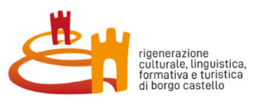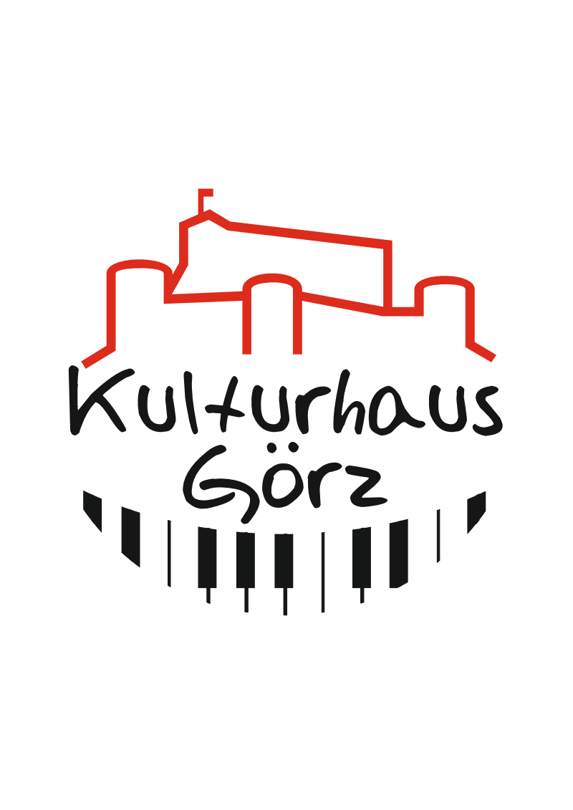

**KULTURHAUS GÖRZ**

Via Ascoli 1 - 34170 Gorizia/ Italy

**kulturhausgo@gmail.com**

**kulturhausgo.summerschool@gmail.com**

**Tel.: 0039-3927203099**

[**www.kulturhaus-go.it**](http://www.kulturhaus-go.it/)

**INTERNATIONAL SUMMER SCHOOL IN ENGLISH**

**FOR YOUNG EUROPEAN STUDENTS AND RESEARCHERS:**

***HISTORY, LANGUAGES AND BORDER CULTURES***

**IN GORIZIA/ ITALY AND NOVA GORICA/ SLOVENIA**

**28 AUGUST – 06 SEPTEMBER 2025**

*Progetto “Mille anni di storia al centro dell’Europa: Borgo Castello crocevia di popoli e culture” CUP F88F22000000007 - Decreto n. 2110/GRFVG del 19.01.2024 Finanziamento PNRR - Next Generation EU per il progetto pilota PNRR M1C3 Misura 2 Investimento 2.1 linea A*

**BASIC INFORMATION**

**WHEN?**

From the 28th of August to the 6th of September 2025.

**WHERE?**

Main location: Gorizia, via Rastello, 38. Italy.

**HOW TO REACH GORIZIA?**

By train: Gorizia is well connected with Udine, Trieste and Venice Airport

By car: Motorway Tarvisio – Trieste, Exit: Villesse, direction Gorizia/ Nova Gorica

By airplane: Closest airports: Trieste, Venice, Treviso, Ljubljana (SLO)

**GOAL?**

The twin cities Nova Gorica/Gorizia are this year the first “borderless” European Capital of Culture in the European history. The Summer School of the cultural association Kulturhaus Görz aims in its second edition once more to offer participants the opportunity to discover the great cultural richness and sociological quality of the coexistence implemented in this territory; this will be achieved through privileged meetings with witnesses, historians, anthropologists, sociologists, artists, tourist guides, visits to the territory, excursions, role-playing games, facilitators and experts in conflict management.

This territory, marked by a deep multilingualism since the Middle Ages, part of the Habsburg monarchy until the First World War, is now experiencing a very crucial moment, as it is in fact an important laboratory of coexistence, of reworking its past through a complex work on memory, often divisive, marked by easy nationalist exploitations and a rediscovery of its multiple linguistic heritage.

The Summer School wants to investigate from a historical, linguistic, anthropological, sociological and economic point of view what is happening in this territory, with particular reference to the history of the 19th century, placing it in a wider European context. The opportunity is to start from the history of this cross-border territory, to imagine together with the participants new scenarios and new solutions at a general level to intercultural conflicts and the peaceful management of territories marked by the coexistence of more national and linguistic realities.

**WHO CAN PARTICIPATE?**

The scholars we are inviting to take part include: young people under the age of 30, university students, doctoral students and researchers from all over Europe studying humanities-related disciplines (e.g. history, anthropology, linguistics, translation, diplomatic science, sociology, political science, etc.)

**HOW TO APPLY?**

Those who are interested will have to submit their CV and a motivation letter with an indication of the scientific and cultural questions they would like to investigate during the International Summer School.

**PARTICIPATION OUTPUT:**

Participants will have to produce, as the final step of the Summer School, a series of video-interviews that will be recorded. In these short video interviews, which will be available to the public at the end of the Summer School, participants from different European countries and areas will express their ideas on how to transform the path of integration and reworking of history commemory undertaken by this territory.

These video-interviews will be part of a video-installation that will be displayed in via Rastello 38, on monitors inside and on the windows.

**COSTS?**

**The entire teaching, laboratory and hiking proposal is considered an essential part of the program and will be FREE OF CHARGE +.**

**Participants will be able TO STAY FREE OF CHARGE IN GORIZIA +.**

**Travel costs and meals are NOT INCLUDED AND HAVE TO BE COVERED BY THE PARTICIPANTS -**

**MAXIMUM NUMBER OF PARTICIPANTS: 20**

**LANGUAGE OF COMMUNICATION**: **ENGLISH**

**APPLICATION DEADLINE: 15TH OF JULY 2025**

**We are looking forward to meeting you in Gorizia!**

**Any questions? Please contact Luka and the Kulturhaus staff:**

**E-Mail -** [**kulturhausgo.summerschool@gmail.com**](mailto:kulturhausgo.summerschool@gmail.com)

**Tel.: 0039-3927203099**

